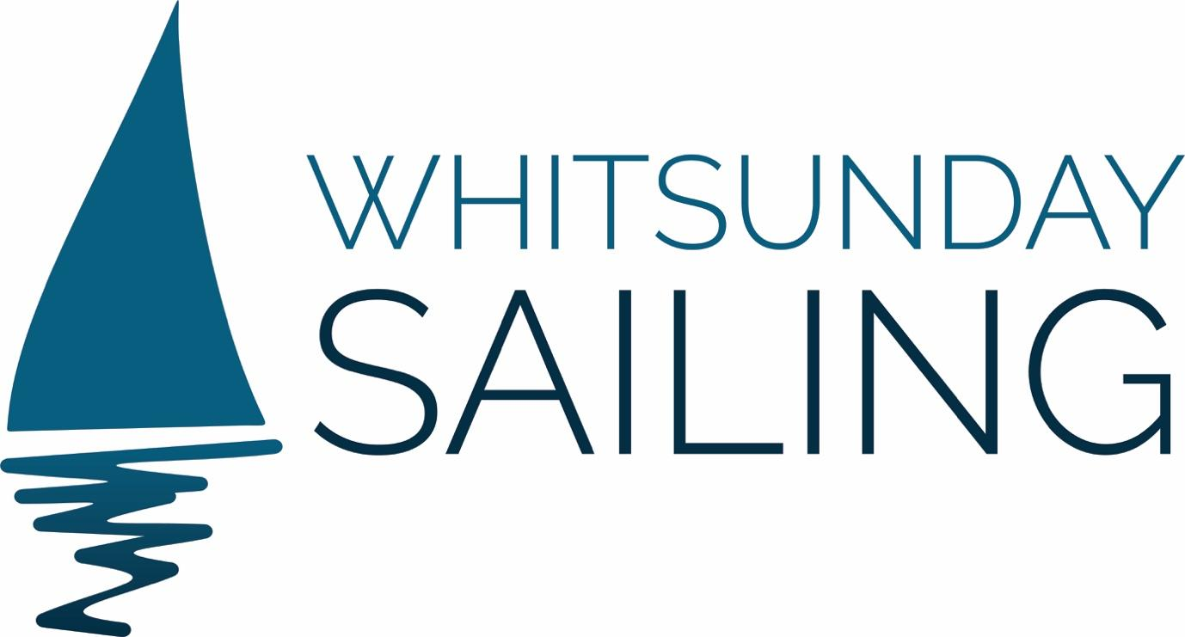

TERMS & CONDITIONS

Please note we operate sailing vessels. We do endeavour to use our sails but that depends upon winds and weather conditions.
Please also note that it takes 3 hours to reach Whitehaven Beach which is some distance from Airlie Beach. The journey is part of the day.
Also, as we have sailing vessels, please also note you may get wet from waves, depending on the conditions. We are inside the Great Barrier Reef which means we are more sheltered than in the open ocean but if you have not experienced a sailing vessel, it is quite different for eg from a ferry. If you have any questions at all about this, please contact us.

PROVIDENCE V DAY & SUNSET SAILS
​
Our minimum numbers are ten people in order to sail. You will be offered an opportunity to transfer to another day or can ask for a full refund.
All bookings can only be confirmed with full payment for the sail.
We permit cancellations 72 hours before travel, otherwise there is no refund. If we cancel for any other reason ie due to weather, we will offer you the opportunity to sail on another date or give you a full refund.
Prior to boarding should you be suffering from COVID symptoms (or are in close contact with someone who is) please inform us immediately.
We reserve the right to change the route or destination if necessary e.g. weather conditions.
If you lose or damage snorkelling gear or stinger suits you will be charged for the replacement of lost goods via EFTPOS on the boat.
It's a barefoot experience. We collect your shoes upon boarding and return them for the Hill Inlet walk on the day sail or on disembarking on the sunset sail.
The Master's directions are to be obeyed at all times.
Whilst we make every effort to safeguard our guests, we cannot be responsible for any damage, personal injury or loss due to the actions of passengers that are beyond our control.
We have a WAIVER that must be signed by all guests (including children via parent/guardian). This will be sent to you at the time your booking is confirmed.
You must inform us of any medical conditions which will be documented in our records. It is your responsibility to make us aware of any conditions that might adversely affect your ability to swim, snorkel or otherwise enjoy the activities provided. For example, we use a Shark Shield on our tender on our day sails and if you are pregnant or have a pace maker you must let the crew know before you undertake any snorkelling activities. We are able to switch this device off. Please note, this only applies to our day sail. Not our sunset sail.
Each guest (or parent/guardian of children or others) must sign indemnity waivers upon boarding provided on our ipad.
All departures and itineraries are subject to weather and maybe changed or cancelled at the discretion of the Master.
Stinger suits are provided during stinger season (November to May) and you are strongly advised to wear these suits which are provided free of charge. If you fail to take this advice, you do so at your own risk.
Please note, we do not provide wetsuits but these are available for hire the day before the sail before 4pm at Aqua Dive.
We are fully licensed. No BYOG thanks. We do have a 'card only' bar.
​

PRIVATE CHARTERS
ITINERARY
Itinerary can change due to weather/tides.
The Master must be obeyed at all times.
50% deposits are required for all private charters and the balance MUST be paid a week before the charter.
PAYMENT
If you have chosen to pay a 50% deposit, the final amount must be paid within a month of the sailing date.
Cancellations 30 days before departure will result in 100% of the payment. Cancellation 60 days before departure will result in 50% of the payment.
An 5% administration fee will be charged for any cancellations outside of the periods noted above.
Travel insurance is strongly advised to protect against unexpected circumstances which might result in cancellation of the booking.
You will receive a refund if we cancel for any reason or the option to move to another sailing date.
ALCOHOL
No BYOG please. We are fully licensed. We do have a shop online from our home page where private charter guests on either vessel can prepurchase or email us with any special requests.

MILADY

Private Charters

Private charter bookings will be confirmed on payment of non-refundable 50% deposit.
Private charter balance payments to be made on the date of the charter unless requested otherwise by the guest.
Cancellations 30 days before departure will result in 100% of the payment. Cancellation 60 days before departure will result in 50% of the payment
Travel insurance is strongly advised to protect against unexpected circumstances which might result in cancellation of the booking.
We permit cancellations for COVID reasons within a month of the travel date (ie border closures/lockdowns). There will be a 1% admin fee applied to all cancellations. Alternatively, we can offer you the option of a gift card for the full amount paid for your travel at a later date.
Waivers must be signed prior to boarding by all guests including parents/guardians signing on behalf of children.
​

CABIN CHARTERS

Please note we have ALL 3 CABINS need to be booked before the sail is confirmed. When booking please check online or with your agent and preferably choose a date where at least one or both other cabins have been booked as this will avoid disappointment if we are unable to sail. We will endeavour to contact you two weeks prior to the sailing date if we have been unable to fill all of the cabins. There is also the option to charter MiLady privately if you have to book a specific date.

Cabin charter bookings will be confirmed on payment of non refundable 50% deposit.
Cabin charters are to be paid in full on the date of the sail unless requested otherwise by the guest.l.
Cancellation 60 days before departure will result in 50% of the full amount of the cabin being forfeited.
Cancellation within 30 days before departure results in forfeit of full cabin charter price.
An administration fee of 5% will be applied for all cancellations outside of the above categories.
We permit cancellations for COVID reasons within a month of the travel date (ie border closures/lockdowns/covid positive test). There will be a 1% admin fee applied to all cancellations. Alternatively, we can offer you the option of a gift card for the full amount paid for your travel at a later date at the same price as your initial booking with no admin fee.

Other Conditions

All guests WAIVER that must be signed by all guests (including children via parent/guardian). This will be sent to you at the time your booking is confirmed. Prices are based on twin-share accommodation unless otherwise specified.

Whilst we make every effort to safeguard our guests, we cannot be responsible for any damage, personal injury or loss due to the actions of passengers that are beyond our control. All departures and itineraries are subject to weather and maybe changed or cancelled at the discretion of the Master. The Master's instructions must be obeyed at all times.

Stinger suits are provided during stinger season (November to May) and you are strongly advised to wear these suits which are provided free of charge. If you fail to take this advice, you do so at your own risk.

You must inform us of any medical conditions which will be documented in our records. It is your responsibility to make us aware of any conditions that might adversely affect your ability to swim, snorkel or otherwise enjoy the activities provided. Each guest (or parent/guardian of children or others) must sign indemnity waivers sent via email at the time of booking.

REFUNDS

If we cancel the sail due to winds or other reasons, you should be entitled to a refund or the option of changing the date. However, the terms and conditions of refunds depends on the travel agent you booked through as we do not immediately receive your funds from many of the agents. If you have booked direct through us, you will be entitled to a full refund which can be processed immediately if you cannot change to another date for your sail with us.

